This Week in Grade 4 McConaghy - Tuesday, Nov. 12 – Friday. Nov. 16, 2018

Lest We Forget!
I hope everyone found the opportunity to remember those who fought for our freedom and those who continue to protect us!
On Thursday, November 08, Barkers Point students and staff remembered those who lost their lives, those who fought for our freedom and those who continue to serve and protect us. A huge thank you to Mme Tremblay for organizing an amazing assembly! It was certainly heart touching. Thank to Xavier for sharing his Remembrance Day Acrostic Poem. As always, my student’s behavior was impeccable! I am always so proud of them. They are wonderful role models for younger and older students. They always live up to my expectations and make me proud!
On Wednesday, my class along with Mme Tremblay’s class will be part of a Children’s Rights Presentation. I always talk to students about Rights, Responsibilities and Privileges. This presentation will elaborate on what my students know and understand regarding The Rights of The Child. I find using the terms Rights and privileges really help students understand of what a privileges are and that privileges are earned. This is common everyday language in my classroom.
Does your child or some child suffer from anxiety? It is important to remember that anxiety can mask itself in many forms. Often we do not recognize anxiety. On Thursday, November 15 Mr. Campbell will give a presentation on Children who worry too much. I highly encourage you to attend. I plan on attending. Mr. Campbell always has great information to share! The presentation is at 6:00.
Next Saturday, will mark Barkers Point First Annual Family Fun Run. If you are interested in more details please ask your child to go to the office to get an information sheet. This is certainly a win – win situation. Families spending time together, while getting physical exercise and enjoying the outdoors.
On Thursday, I sent home a notice regarding Barkers Point Christmas Dinner. I have attached a copy of the letter just in case you did not receive one! Please note late orders cannot be accepted!
It is just about that time of year, First Reporting Period! Report Cards will be sent home on Monday, November 23. Included in the Report Card Envelope will be form to complete and return regarding Parent Teacher Conference times. Please complete and return. Please note that conferences will be assigned on first come first assigned basis.
What we will be learning/ working on this week
Literacy
Our focus for the next two weeks will be Nonfiction Texts. We will review / learn the various features of nonfiction texts, how to use the Table of Contents, Index, Glossary in Nonfiction books. We will use magazines as one example of nonfiction texts. I will share the most recent issue of National Geographic,( not to worry it has been censored). The most recent edition explores The Vikings – Lords of Sea and Swords. I think students will be very engaged / interested in learning more about the Vikings .Learning about the Vikings will partner well with Social Studies. In Social Studies we are learning about Explorers.
The second nonfiction source we will be using is Popular Science Magazine. We will read about ; What Makes a Boomerang Come Back, What does Space Sell Like, Could We Live on Mars, Why Do We Yawn, Why Do we Laugh, How Does the Brain Work, Why Do We Hiccup, Why Do We Have Fingerprints, Why Do Cats Purr, and Why are Bees Disappearing?
Grammar
We will continue with our Daily Grammar Warm Up. This assists students in keeping concepts we have learned fresh in their memory and reinforces concepts we had previously covered.
Parts Of Speech
Yippee! Students will be introduced to interjections and attempt to include interjections in their writing. Interjections are words or phrases that express emotion, meaning or feeling. Interjections are usually used at the beginning of a sentence. Including interjections in writing pieces will help give the piece of writing Voice.

Writing
Students continue to create recount writing. The focus this week will continue to be word choice, including a strong ending and including interjections in pieces of writing.
Math
We are very fortunate to have Liz , Math Lead, join us for the next couple of weeks. We will continue to work on understanding place value and representing numbers up to Tens of Thousands in various forms.
On Tuesday, students will be given a pre assessment on subtraction and addition. The pre-assessment will include simple single digit addition and subtraction up to 3 digit plus 3 digit with carrying and 3 digit plus 3 digit with regrouping. This pre-assessment will inform me regarding where the students in my class are functioning in regards to addition and subtraction. My lessons will be based on the results.
Students are expected to continue mastering Times Tables up to 12 multiplied by 12. I cannot stress how important it is for students to master their Multiplication facts. Several times a week students will be given time multiplication facts questions to answer. The results will be recorded. For students who are struggling with master multiplication facts it is important to practice nightly.
Health
The characteristic Barkers Point students will be learning about for the month of November is Self-Regulation. We will continue to learn various calming techniques. We will also be learning the various parts of the brain. This will be in connection with understanding self-regulation. We will read My Fantastic Elastic Brain and complete activities associated with this book.
UNB Student Nurses will be visiting us on Friday to continue to teach us about healthy living.
Social Studies
We will continue learning about the Titanic. We will also continue the unit on Exploration. Our Literacy unit on non-fiction texts will be used to support our learning about explorers.

Science
The science unit on Rocks and Fossils will continue to be investigated. This will be partnered with our Non Fiction unit in Literacy using the Popular Science magazine.
Everyday students should be reading at home for least for 20 minutes nightly. I hope that students are setting aside at least 20 minutes every day to read at home.
Benefits of Home Reading
Starting in kindergarten, if a student reads 20 minutes a day at home, they will hear 1.8 million words per year. They will have read for 851 hours by 6th grade and on standardized tests, they will likely score better than 90% of their peers.
This is compelling data on the benefits of encouraging your child to read.
Helps in language development
From the time your child is born, reading out loud is a positive influence. As your child grows, daily reading will help the brain make connections between the written and spoken word, widening vocabulary in the process.
Adding to that benefit, vocabulary knowledge equates to masterful spelling. In fact, reading, spelling and vocabulary are critically important to a child's lifelong achievement.
Promotes brain development
Educators have long said reading makes people smarter, and there’s research backing them up. A recent study conducted by the American Academy of Pediatrics found reading to children of any age wakens a number of regions in the left part of the brain. The areas in the brain that become active involve understanding the meaning of words and concepts tied to memory.

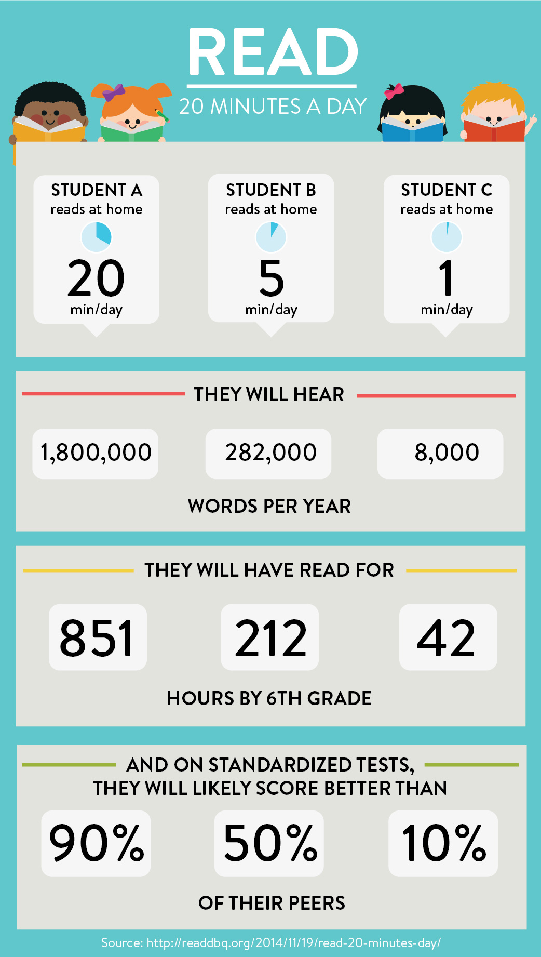

Aids in understanding of a world outside our own
Reading is more than just translating written words into verbal form; it is about understanding those words were once ideas in the minds of great thinkers. It is about realizing those ideas can be connected to personal experiences.
Through daily reading, children are exposed to a world outside their own reality. It expands their know-how, opens their minds and creates the potential for a continuation of ideas and an endless number of possibilities.
Additionally, children can take advantage of a Kindle to improve reading skills through the development of word fluency and comprehension. Word Wise, for example, places short and simple definitions and synonyms directly above difficult words in text, so kids can better understand the material and keep reading with few interruptions. Vocabulary Builder automatically takes words users look up and creates flashcards with definitions and word usage examples.
Is your child struggling with reading or writing? Students in grades K-12 can sign up for free literacy tutoring at the library. A trained tutor can help you improve your literacy skills (reading, comprehension, writing) or assist you if you are an ESL learner. Call 506-460-2806 to register for this FREE program. Space is limited.
Wednesdays at 3pm-5pm (for children in K-Grade 5)
Wednesdays at 5pm-7pm (for students in Grades 6-12)
Please note that I am requesting a Parent Teacher Conferences with every child’s parent(s). Even if you do not have any concerns I would like to connect with you. It is important for your child to see that we are partners. This is an important message.
Have a wonderful week! Stay in touch!
Mary Ann
Mary.Mcconaghy@nbed.nb.ca
453-5402

